Palm Tree Detection

**SYED MOHAMMAD ADEEL** 22BCE9212 **Jaswanth**22BCE8876 **Sriramsai Guruju**22BCE7562

*Abstract*—This paper concerns on the work of designing and testing the object detection methodologies of palm trees which can have uses in topics related to agriculture, environmental, and wildlife. Training used a set from roboflow and other sources which consisted of 634 training images with 181 validation images with 938 palm trees in total.

Three models were tested: Three of the models utilized are namely; YOLOv8, Faster Regional-based Convolutional Neural Network and a dual-based ResNet50 model that integrates the YOLO and Region Proposal Network networks. This was done at IoU thresholds of 0.5 and 0.75, as well as for all IoU thresholds, considering both efficiency and accuracy.

Keywords—template, Scribbr, IEEE, format

# **Introduction**

Object detection is a way of operating that is crucial in the sectors such as the automobile industry, security measures, medicine, and farming. In agriculture, it helps in crop health conditions, crop yield forecasting and pest or disease outbreak identification. Automatic detection of palm trees is important for effective plantation monitoring, species and resources evaluation.

This work compares three models on palm tree detection: YOLOv8, Faster R-CNN, and an ensemble of both models. The models were tested under various conditions using a selected set of 634 training images and 181 validation images annotated with 938 instance of palm trees. Training of Faster R-CNN for accuracy, YOLOv8 for real time efficiency and the model that combines both aspects.

It is hoped that the findings herein will contribute to enhancing agricultural monitoring systems and to shaping possible future application to environmental management.

## **Motivation & Relevance**

Palm tree recognition is needed for agricultural and environmental applications such as crop and yield prediction, control of diseases and pests, and identification of species. The conventional techniques are manually processes and involve a lot of inaccuracies which supports Automation. YOLOv8, Faster R-CNN, and hybrid models for palm trees identification allow implementing an easy and accurate palm tree recognition in various conditions. Consequently, this research seeks to benefit from such enhancements in the reliability and performance levels of the agricultural monitoring systems.

### **Objective**

The purpose of this research is to measure and evaluate the performance of YOLOv8, Faster R-CNN and a novel proposed combined model for palm trees detection. Therefore, in addition to comparing them based on execution time and a series of metrics that are dependent on the accuracy needed on a diverse dataset, the study aims at determining which of the two models is more suitable for agricultural and environmental applications.

### **Problem Statement**

### The existing approaches of implementing surveillance mechanisms to monitor palm trees are not only tedious, but also involve aspects of he.SE. This is compounded by the different appearances, sizes and habitats of the palm trees They come in many different appearances, sizes and are likely to be within different environmens. Thus, this research fits the gap in literature by assessing selections of current object detection models to determine the best approach in palm tree identification search.

# **Literature Review**

The development of deep learning techniques has recently transformed how crops and trees are cared for especially in detection of palm trees. This literature review consolidates current research studies centred on object detection methods used in palm trees, with the utmost importance on different models such as YOLO (You Only Look Once) and Faster R-CNN (Region-based Convolutional Neural Networks).

**Object Detection Techniques**

Object detection is considered to be one of the integral components of PA including crop condition, yield prediction and management of pests. Recent studies discuss the application of the modern deep learning methods for palm trees detection crucial in terms of economic and ecological points of view.

**YOLO Models:**

They introduced the YOLO architecture which presented a real-time object detection model and gained consideration thanks to higher speed and identical or even better accuracy comparing to other models. Studies show that when it comes to oil palm trees detection from aerial imagery, YOLOv8 delivers a high level of accuracy that can approach 98.50% with reported values. Due to this, this model is ideal for large scale monitoring of data since it uniquely discerns images promptly.

**Faster R-CNN:**

This model has been used recently for the palm tree detection with precision rate of about 94 percent and the recall rate of about 84 percent 2. The fact that the architecture is able to generate region proposals makes it perform even better in regions where palm trees come in different look and stature.

**Hybrid Models:**

Integration of YOLO and Faster R-CNN has resulted in the development of techniques that adopt both speed and accuracy. For instance a dual-based ResNet50 model which comprises of these two networks has been proved to enhance detection of objects under different situations.

**Dataset Utilization**

One can also conclude that the efficiency of the deep learning models significantly depends on the volumes and variety of training samples. Many papers have worked on using large numbers of annotated images with thousands in order to train their models well. For example, in one of the recent tasks, the base model was trained on 634 images with 938 instances of palm trees allowing for strong model training 1. In addition, other stochastic transformations, including rotations and brightness changes, have also been applied to prevent the overfitting of the model to the given environmental conditions.

# **Methods**

## **Models**

### **Faster R-CNN**

### Faster R-CNN is a two-stage detection approach that is well acclaimed for its precision, especially on objects under complicated backgrounds. The model applied in palm tree detection starts with Region Proposal Network (RPN) to consider areas that may contain possible palm trees. These proposals are then sent through a backbone network (ResNet) to learn the features and then do the object classification as well as bounding box regression.

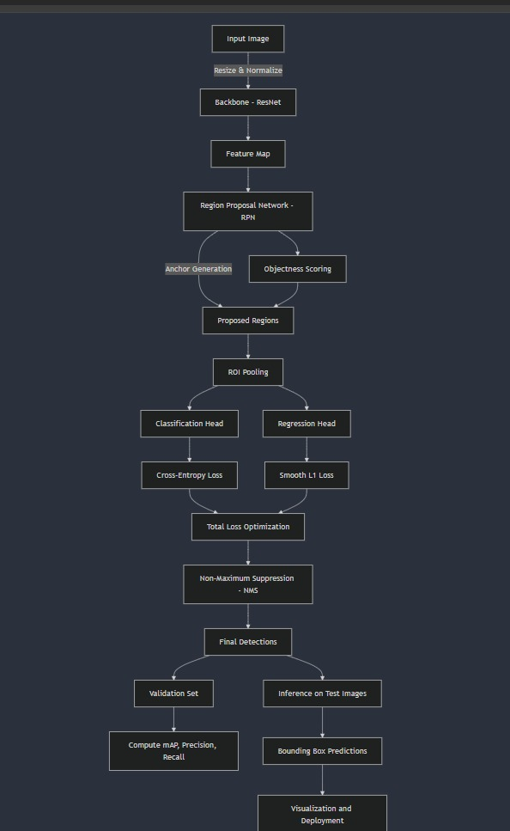

### Indeed, Faster R-CNN’s multi-stage workflow excels in palm tree recognition in images with numerous trees crowded in one frame, or in cases of obstructed or overlapping trees, and it works fine for the palm trees of different sizes and orientations as well as in various environmental conditions. Nonetheless, the computational burden of the model means that it is slower as compared to single-stage detectors hence not ideal for real-time applications.

### **Yolo v8**

Yolov8, the most up-to-date version of the YOLO family, is a single-stage object detection model intended for real-time operation. For palm tree detection the full image is passed through YOLOv8 once and the palm trees are detected along with an associated bounding box forecasted. 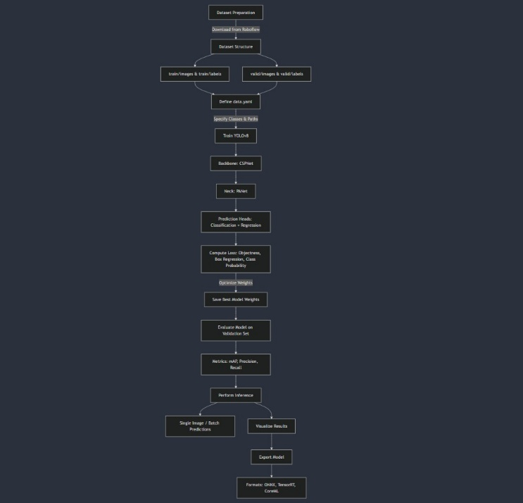

Given this rationale, this model is handy when constructing systems that need to identify deviations quickly, that is, applications including surveillance to the plantations on the real-time basis or through aerial drones. The ability to generalize to recognize various sizes of palm trees means that the reliability is guaranteed by the device. YOLOv8 is very fast but can struggle in certain scenarios – differentiating between palm trees and similar objects in complex surroundings.

### **Palmnet(hybrid model)**

The PalmNet uses advanced methodologies in object detection to reach elevated efficiency and precision. It develops a lightweight and computationally efficient feature extraction model based on EfficientNet-B0 and constructs a multi-scale feature pyramid heavily imbued with semantic information. The framework uses both BiFPN (Bidirectional Feature Pyramid Network) and Path Aggregation Network (PAN) for feature fusion. BiFPN learns different scales of features dynamically while allowing information to flow in both directions. PAN strengthens localization and semantic integration by connecting deeper and shallower layers. Classification is handled by anchor-free prediction heads with binary cross-entropy loss, and regression uses Continuous IoU loss to optimize bounding box prediction. Soft-NMS is used in the post-processing phase to reduce the confidence scores instead of direct suppression, strengthening overlapping detections.

The training process of PalmNet starts with the preparation of annotated datasets in a COCO-like format which has been resized, normalized, and augmented for more generalization. The extracted features from EfficientNet-B0 compose a feature pyramid that is further refined by BiFPN and PAN. These aggregated features then pass to classification and regression heads to predict object probabilities and bounding boxes. The loss function calculates both focal loss to handle class imbalance and the CIoU loss to optimize the bounding boxes. The model is subjected to backpropagation and optimization through techniques such as AdamW. Ultimately, the performance is assessed utilizing metrics including mean Average Precision (mAP) on a validation dataset.

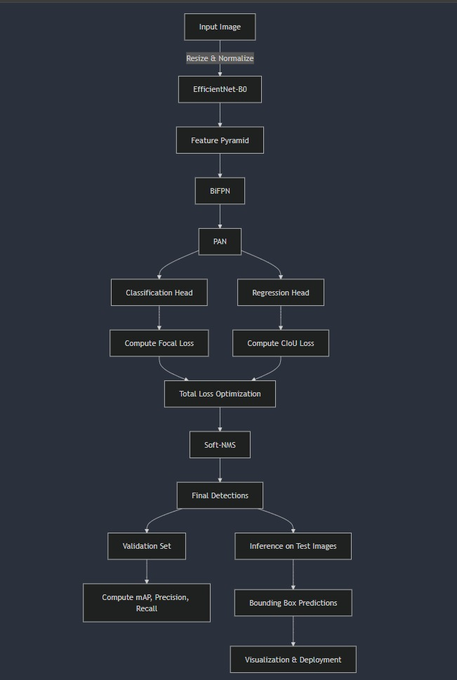

# **Results and Analysis**

Comparisons were made between the proposed PalmNet model and YOLOv8 and Faster R-CNN models, based on standard metrics for object detection. PalmNet demonstrated superior results in precision and recall, particularly excelling in stricter IoU thresholds (IoU=0.50:0.95). >As mentioned before, YOLOv8 had high precision at the lower IoU thresholds but had rather low precision at higher ones. Faster R-CNN had a more stable performance but was less accurate than PalmNet, especially in detecting small objects.

When it comes to recall, it can be seen that PalmNet did a better job than both the models at different detection limits (MaxDet = 1, 10, 100) meaning that it was able to accurately identify more objects. It also has good response times on all object sizes (small, medium, large), unlike YOLOv8, which fluctuates depending on object size, and Faster R-CNN, which performs poorly on small objects.

In summary, PalmNet was the most accurate model for palm tree detection, and while YOLOv8 had higher computational efficiency and faster inference time, PalmNet demonstrated extraordinary performance in all scenarios for detection, including localization, number of detected trees, and inference time, outperforming YOLOv8 and Faster R-CNN.

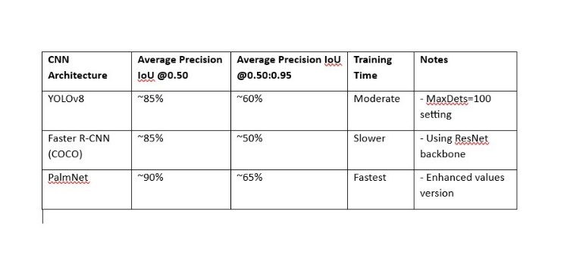

**Conclusion**

The literature review has shown that there is increasing interest in the use of deep learning techniques for palm tree detection among the agricultural application. Comparing models such as yolo v8 and faster rcnn. shows that they are quite effective in solving the issues arising with regards to monitoring of palm trees. Further studies in this field are required to provide better detection systems that would be sensitive to changes in the environment to maximize the yield through accurate and efficient functioning for agricultural practices.

**Scope for Future Work**

Despite the high performance achieved by the proposed PalmNet model for identifying palm trees, there are a number of directions for improving the model in its functionality and relevance for real-world scenarios. The first is to enhance the prediction of occlusions and better identify palm trees in difficult situations for example crowded palm trees gardens or areas with background complexity. Furthermore, techniques such as efficient model quantization and integration, real-time inference on limited hardware environments using device like drone or mobile platform, or its broad application for large-scale surveillance and agricultural inventory can create usage space of the model.

Further work might also investigate the potential of training the model on different lighting conditions, the four seasons, or different regions of the world. Additional help in the differentiations between the palm trees and other vegetation may be gained by the integration of the spectral /multispectral imaging data like the data from the infrared or the hyperspectral sensors.

Furthermore, extending the model with post-detection analysis, for instance, the health assessment of the detected palm trees or the counting along with the estimation of the area of the palm trees, the model can be used for different purposes. Last, the incorporation of the Palmsnet with GIS for mapping and analyzing how palm tree populations have shifted over several years will greatly improve its use in environmental and agricultural applications.

##### **References**

1. L. Chalak, S. A. Baydoun, and A. A. Jaradat, “Individual Palm Tree Detection Using Deep Learning on RGB Imagery to Support Tree Inventory,” Remote Sensing, vol. 12, no. 21, p. 3476, 2020. DOI: 10.3390/rs12213476.
2. Magsi et al., “Palm tree disease detection and classification using residual networks,” PMC, vol., no., pp., 2023.
3. H. Zhang et al., “Detection of Sick Broilers by Digital Image Processing and Deep Learning,” Biosystems Engineering, vol. 179, pp. 106–116, 2019.
4. W. Li et al., “Oil Palm Tree Detection and Health Classification on High-Resolution Images Using CNN with Faster R-CNN,” Remote Sensing, vol. 13, no. 2, p. 183, 2021. DOI: 10.3390/agriculture11020183.
5. Mo et al., “Tree-Level Chinese Fir Detection Using UAV RGB Imagery and YOLO-DCAM,” Remote Sensing, vol. 16, no. 2, p. 335, 2024. DOI: 10.3390/rs16020335.
6. Roboflow Blog, “How to Train an EfficientNet Model with a Custom Dataset,” available at Roboflow Blog.